RENTAL DIVISION PLAYBOOK

WHAT IS IN THE AGENT PORTAL (AKA THE PORTAL)?
The Portal is updated periodically to continue to improve our systems and convenience for our Team Members to navigate through their new and existing rental transactions.
HOW TO GET INTO THE PORTAL
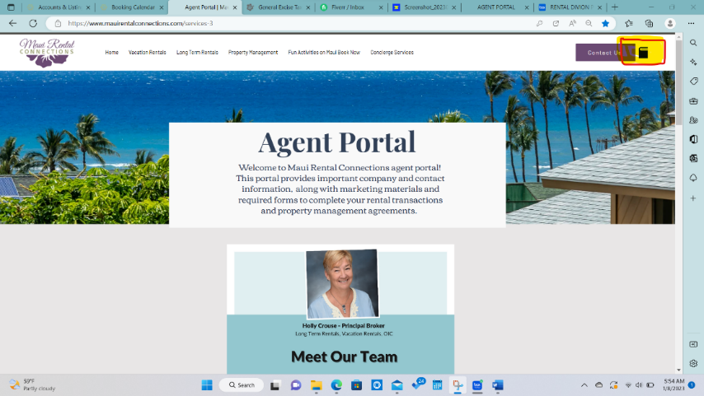
Go to our website: www.MauRentalConnections.com
On the top right hand side where you will see a purple box that says Contact Us. There is a little file folder.
Hit the file folder, as that will bring you to the back side of the website that has our Portal- for agents use.
The password is Agent808. (don't forget the period after 808)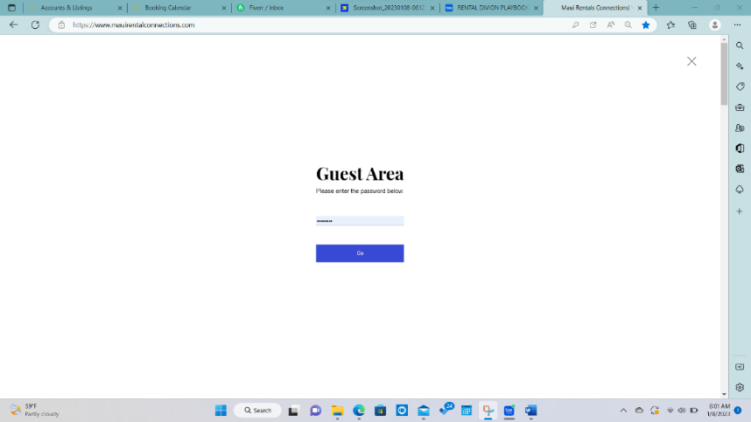

HELPFUL ITEMS YOU WILL FIND IN THE AGENT PORTAL
PROPERTY MANAGEMENT FORMS
- The Portal has the most up to date forms for Long Term Rentals, Vacation Rentals and On Island Contact Representative forms.
- All the forms to Onboard a New Account- forms for not only your client, but also for internal paperwork.
- Direct Deposit form,
- W9 for housekeepers and Vendors, etc
- Misc Legal Forms including: Addendums to Lease, Deposit Summary, Inventory Forms, etc.
- Marketing items- Company Brochure, Welcome Book, QR Code, Web listing Form

IN THE PORTAL, ARE THE FORMS ONBOARDING FORMS FOR ALL PROPERTY MANAGEMENT ACCOUNTS
- Once in the Portal, go down to “PROPERTY MANAGEMENT & RENTAL FORMS. “
This is the place you will find all the forms you will need to Onboard a New Account.
- Make sure to fill out every space on the Onboarding form. If the space does not apply, just enter NA in that spot. This will save several calls confirming things for the staff working on your file.
LINKS TO FREQUENTLY USED PROGRAMS
MAINTENANCE & VENDOR CONTACTS
THESE ARE LISTS OF CONTRACTORS AND CLEANERS WE HAVE USED IN THE PAST. SOME MAY NO LONGER BE ON ISLAND, HOWEVER, MANY ARE.
- Links include Handyman & Repair Contractors (plumbers, electricians, etc)
- Housekeepers
- Helpful list of what is needed to furnish a home
- Baby furniture, baby items to rent for visitors
- Personal Shopping- Link to resource to order groceries for guests, and contact info of our Personal Shopper at Macy’s for purchases with discounts for linens, towels etc.
SYSTEMS & TECHNOLOGY
RAM- aka Realtor Association Maui this placesetter takes you directly to the Dashboard of RAM where that you can access the MLS, and all the tools RAM provides their members.
DOCUSIGN- Electronic Signature Software
TRELLO- A project management software- excellent to managing daily tasks, assignments to assistants and a program that team members can collaborate with when managing projects.
IGMS- A Vacation Property software system that allows 1 place to manage rates on multiple platforms, add direct bookings, have access to guest info and calendars.
INNAGO- A software system for Long Term Rentals- provides renters to report maintenance requests to the PM, provides renters a source to pay rent online, provides contact info for renters, shows attempts to pay rent and calculates late fees, give renter access to the Lease.
THE BOX- An Electronic File Cabinet that holds files on all transactions, Team Folders, Forms that are not uploaded in the Portal, Marketing Info, etc.
HELPFUL RESOURCES- Information regarding GET and TAT taxes.

YOUR MRC TEAM OF PROFESSIONALS AT YOUR SERVICE
THE ROLES OF OUR ADMIN TEAM & EMAILS
Contact the Marketing Concierge with any questions or concerns regarding the Website, QR codes or any personal marketing that you would like to hire the Concierge to do for you. You can reach her at Concierge.MauiRealtyConnections@gmail.com
Contact the Bookkeeper who specializes in short term/vacation rentals by emailing him at MRC.AnthonyW@gmail.com
Please contact the Executive Assistant to send out the prepared legal documents to your clients and any Onboarding questions. You can reach her at MRC.ExecAsst@gmail.com

TOOLS & SYSTEMS ARE GREAT, BUT COMMUNICATION IS KEY!
Manage Expectations-
All of the invoices you receive from your vendors, after they are approved by you, please email them to MRCvendors@gmail.com This is where the bookkeeper will go to find invoices in one place for each property.
Tell your handymen, housekeepers and vendors that we pay invoices within 30 days of receipt. That way they will not expect payment sooner and be upset they haven’t received it.
Remind your owners when there is a Holiday that falls the first week of the month or last day of the month, that there is a good chance that Financial Reports and/or Rental Income Deposits will be received between the 15th and 20th of the month. These circumstances limit the business days that are within the timeframe to obtain income sources from all the sites, compile financial reports to agents for review and approval and get them out to the owners.
Once you have your paperwork for your new rental account completed:
- upload all the signed documents, and photos into the BOX, in your Team Folder’s Account.
- Email the Executive Assistant, that you have a new account, attach the Onboarding form, and they will go to the Box for other documents they may need to set up the account internally.
- The Executive Assistant will then notify the Marketing Concierge, so she can create the listing on the Company Website. Please attach the Website Information Sheet, and the QR code request sheet.

- Email addresses: VR Bookkeeper MRC.AnthonyW@gmail.com
Executive Assistant ExecAsst@gmail.com
Marketing Concierge Concierge.MauiRealtyConnections@gmail.com

Email any emails regarding deposits to MauiRentalConnectionsAcctg@gmail.com
Email any expenses to MRCvendors@gmail.com

FILLING OUT A FILLABLE FORM OBTAINED FROM THE PORTAL
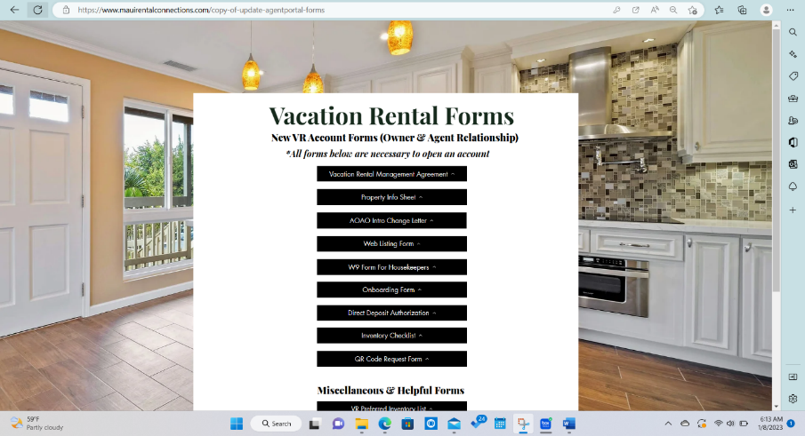
- Choose your form and download it to your desktop.
- Fill it out and Save it to your Computer.
- Attach the form to an Email. Send it to the Exec Asst, and she will send it to your client, or send it to your client for signature yourself.
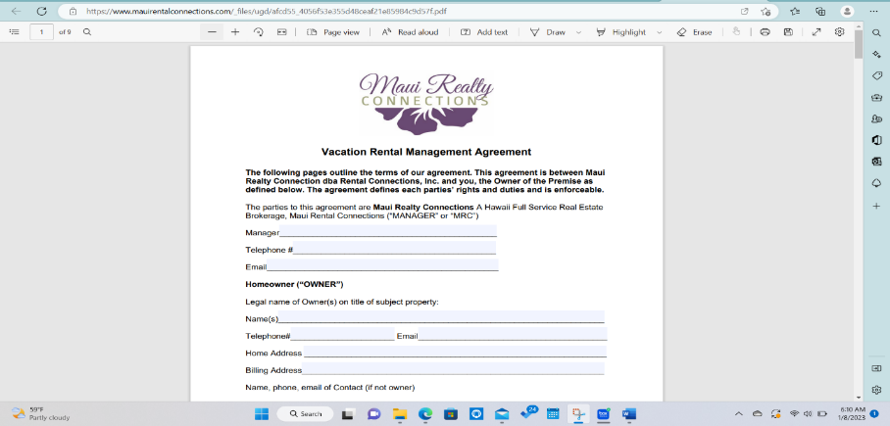
** If changes need to be made based on your arrangement with your client, an addendum to the Agreement should be drafted.

REQUIRED FORMS FOR A NEW PROPOERTY MANAGEMENT ACCOUNT
All required forms to be uploaded by Agent into their Team Folder (Property File)
VACATION RENTAL
Onboarding form- This form is referenced by Bookkeeper, Broker, Agent and Marketing Concierge
Web listing Form- All listings must be featured on our Company website. This form provides information for Admin to create your listing. You will find this form under Marketing.
PHOTOS FROM PROFF PHOTOGRAPHER- no cell phone photos –
W9(s)- for Owner, Housekeeper and any Vendors that are not already in the system- Bookkeeper needs this for 1099’s and tax reporting. Information Confidential.
Direct Deposit-Bookkeeper needs this to issue ACH payments to Owner for their rental income. Information Confidential.
N848 Form- Only if the client is having MRC withhold and pay their GE or TAT taxes.
Property Information Form-This form is referenced by Bookkeeper, Broker, Admin, Marketing Concierge and Agent.
Property Management Agreement- This form is our legal contract for services. Referenced by Broker, Bookkeeper, Admin and Agent.
AOAO Change Form -notifies AOAO you are the new Manager and to provide them contact information in case of emergencies.
OPTIONAL FORMS: QR Code Information Sheet- Only necessary if you want our Marketing Concierge to create a QR Code with helpful information for your guests. You will find the QR Code Info Sheet under Marketing. If the owner is a Foreigner, you will also need a Foreign Tax Form (if owner is Foreigner)

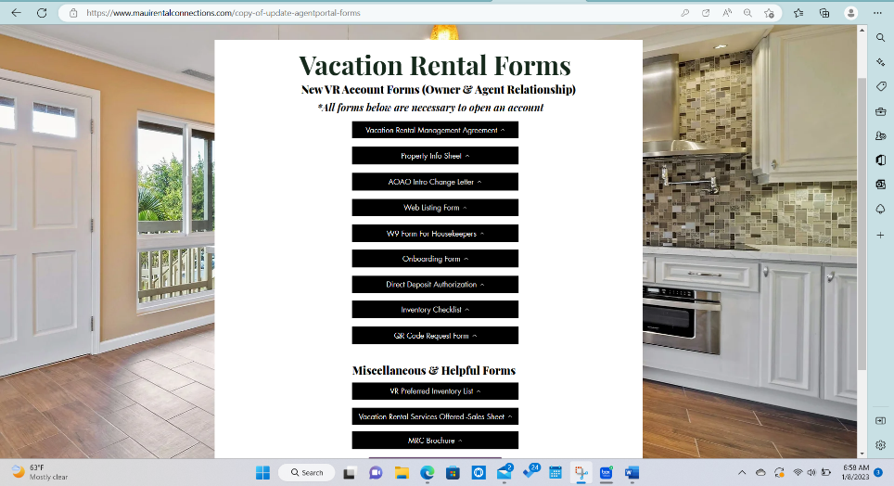

LONG TERM RENTAL
Client/Owner File
Onboarding form-
Web Listing Form- You will find this form under Marketing
Photos from Prof Photographer
W9 from Owner
Direct Deposit from Owner
Property Information Form
Property Management Agreement
AOAO Change form
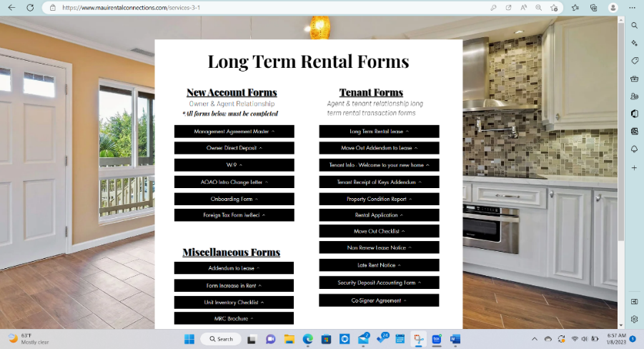

LONG TERM RENTAL
Renter File
Onboarding form with Renter Info
Lease (signed)
Move Out Addendum To Lease
Property Condition Report
OPTIONAL: Inventory- if rental is furnished, Foreign Tax Form (if owner is Foreigner)
UPON LEASE EXPIRATION
Security Deposit Accounting Form
Photos of any Damage or costs to deduct from Deposit
OTHER REQUIRED FORMS WHEN SITUATION ARRISES
RENT INCREASE NOTICE
NON-RENEWAL NOTICE
VIOLATION NOTICE

ON ISLAND CONTACT/REPRESENTATIVE
Onboarding Form
Owner Direct Deposit
Property Info Form
AOAO Info Change Form
OIC Agreement
W9 from Owner
QR Code Information- form found under Marketing
These properties are not listed on our Company Website, so the photos are not necessary, nor is the Website Information Sheet.
Please note that if you are requesting information or a task to be done for you, that your request may take some time to complete, and that an immediate response may not be possible. Be proactive, and provide as much notice as possible and let the staff know what your deadline is for completion of the task requesting. Thank you in advance for your consideration.

Please contact the Principal Broker with any questions or concerns regarding a situation you are concerned about, or any questions you may want answered or advised on. You can reach Holly at MauiRentalConnections@gmail.com

LETTER TO CLIENT/OWNER OF A LONG TERM RENTAL

Aloha!
Welcome to our Maui Rental Connections Ohana! We are so glad you have chosen Maui Rental Connections to handle your property management needs and want to make sure you have a smooth transition in this process.
Financial reports are sent to owners on or before the 20th of each month. Please note that once the renter pays us, it can take a couple of days for their payment to clear our bank...which is often around the 8th of each month and can delay payments to our owners. Our management contract states the deadline for us to deposit your funds is the 20th of each month. We will try very hard to get payments out on or before the 15th, the renter’s payment must clear our bank first so it sometimes creates a delay. There have been only a few times with holidays or extraordinary circumstances that this has been delayed. As long as we have your automatic deposit form, your W9, along with your GE tax number, your file will be set up and we are good to go!
If you should have any questions on your financial statement or any other financial questions regarding your account, please email Myke at MRC.MykeS@gmail.com or contact your property manager.
Thank you for choosing Maui Rental Connections to manage your piece of paradise on Maui!
Sincerely,

Cheryl Kong, Executive Assistant
Myke, Bookkeeper for Maui Rental Connections
Holly Crouse, President

LETTER TO AN OWNER OF A VACATION RENTAL

Aloha!
Welcome to our Maui Rental Connections Ohana! We are so glad you have chosen Maui Rental Connections to handle your property management needs and want to make sure you have a smooth transition in this process.
Financial reports are sent to owners on or before the 15th of each month. Please note that once the last guest that departs on or before the last day of the month, many of the major websites (vrbo, Airbnb etc) do not deposit rental income into our account for a couple of days, and it can take time for the payment to clear our bank...which is often around the 8th of each month. Our management contract states the deadline for us to deposit your funds is the 20th of each month. We will try very hard to get payments out on or before the 15th, Please note with holidays falling in the first or last week of the month, that reports may be delayed. As long as we have your automatic deposit form, your W9, along with your GE tax number, your file will be set up and we are good to go!
If you should have any questions on your financial statement or any other financial questions regarding your account, please email Anthony at MRC.AnthonyW@gmail.com or contact your property manager.
Thank you again for choosing Maui Rental Connections to manage your piece of paradise on Maui!
Sincerely,

Cheryl Kong, Executive Assistant
Anthony, Bookkeeper for Maui Rental Connections
Holly Crouse, President

