CLOCKIFY
- Clockify is the app to track your work daily. Pay dates will be every other Friday, highlighted in yellow for the pay period ending the previous Saturday (Sunday through Saturday).
- For example, the pay date of 04/28 will include the pay period 04/09/23 through 04/22/23.
- Hours must be approved and submitted by the following Tuesday for processing (banking holidays may affect these deadlines and ample notice will be given to all employees about any changes).
- Holidays
- Pay dates
- Pay period for 04/28 pay day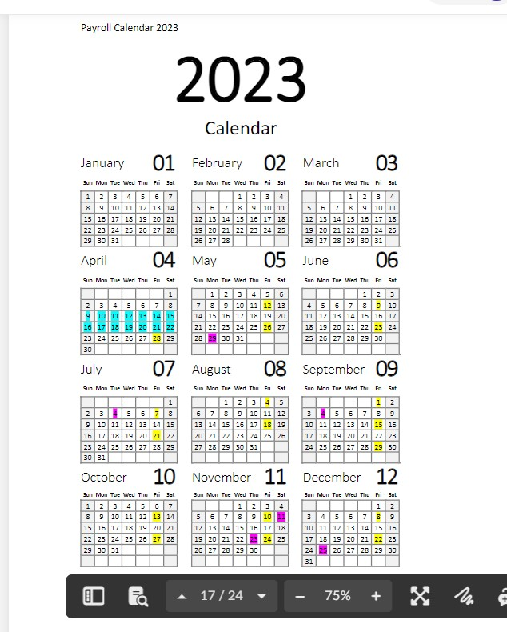
You will be sent an invite to create an account on Clockfiy. Use the top feature of “Time Tracker” to enter your daily work.
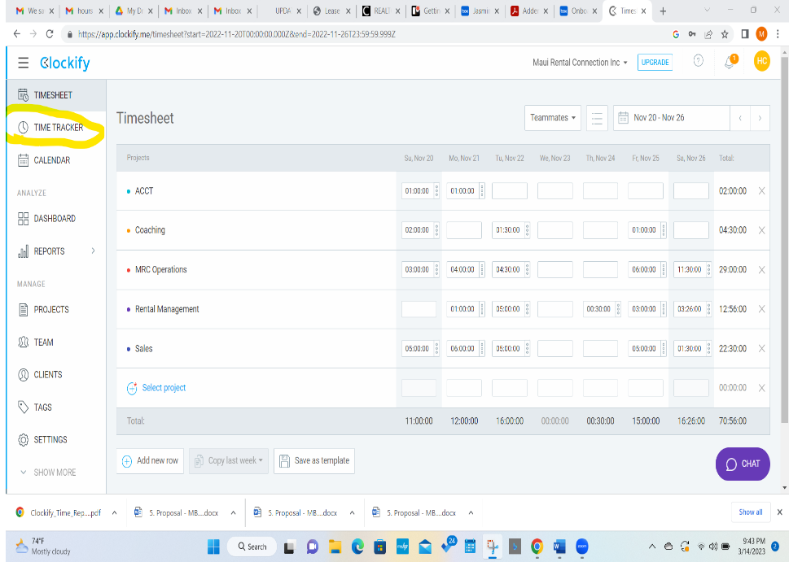 Give a small description of what you did during that time frame so if you are asked you can reference back. If you have small increments of time or forget to hit STOP after completing a task, or small bits of times such as 10 minutes here or there it is ok to combine the time and log it all at once. Be fair but conscious of how much time you spend.
If you are working on a project for an agent as the Marketing Concierge, make sure to hit the $ sign as this is time that will be billed to the Agents quarterly.
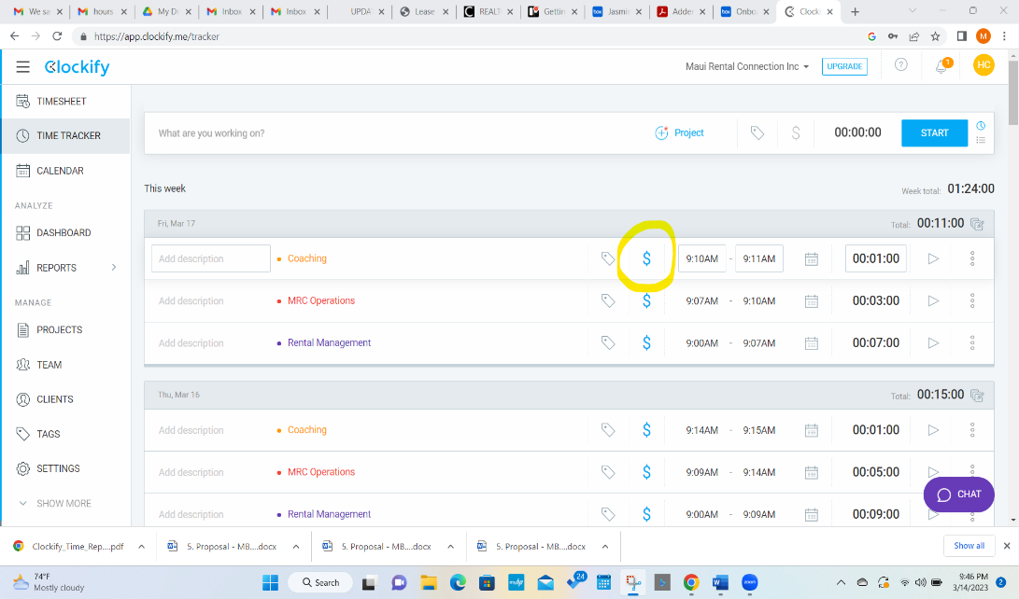

The Monday following the end of the pay period, upload a Summary Report of your hours into THE BOX for our bookkeeper to retrieve and draft your paycheck. Upload it in the Box under: Admin or Staff Only folder, then drill down to “Accounting” then “Time slips” and finally upload it into your employee file.
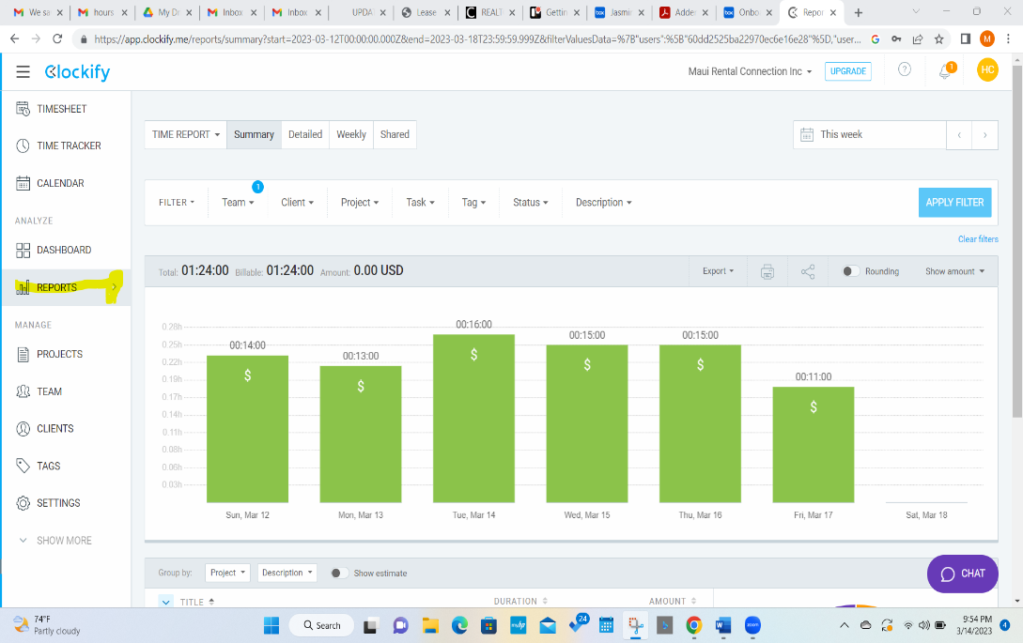To create a Summary Report, go to Reports in Clockify, choose Summary Report, in the Filter Section, choose Team and check off your name, look at the dates to make sure the report is including the period you have worked and hit “apply filter”.
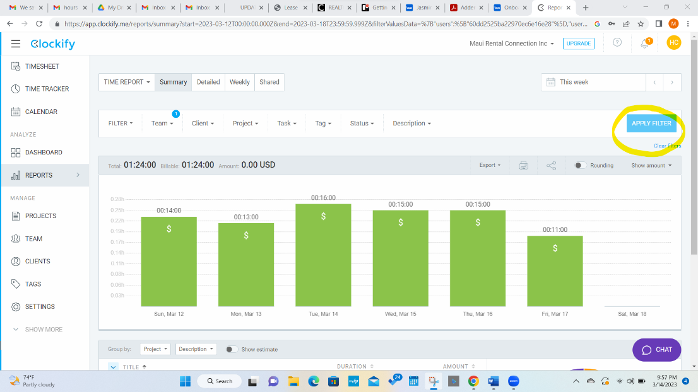 Last step is to go to Export and choose save as a PDF.
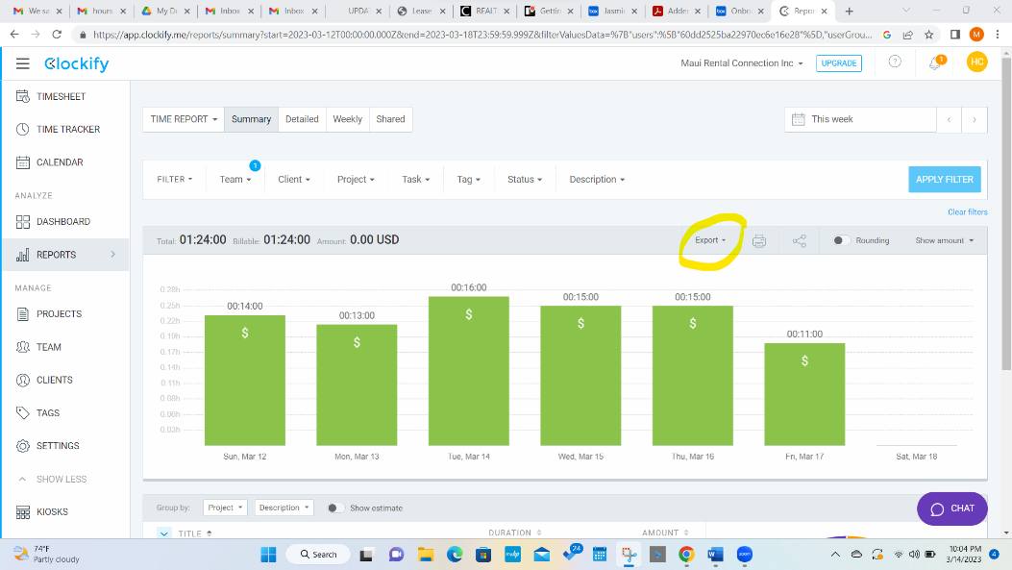The summary report will show a graft showing your projects and time spent. This is your time sheet and the record of your reported hours.
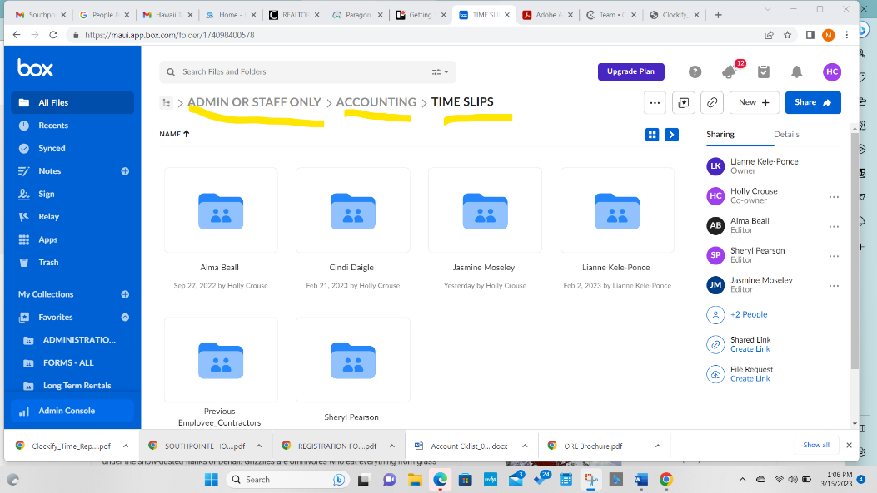
Upload the Summary Report in the PDF format into the BOX under ADMIN OR STAFF ONLY folder then drill down to the ACCOUNTING folder and finally hit TIMESLIPS and look for your file. The bookkeeper will go there to retrieve your hours to draft your pay check. If your clockify pay summary is not in the box, your pay will be delayed until next pay period. The bookkeeper will not send out reminders to you- so please add this to your calendar to do.

